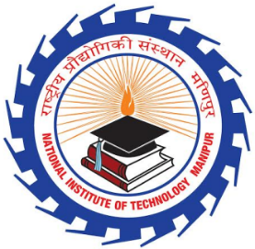 | Department of Electrical Engineering  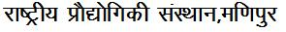  NATIONAL INSTITUTE OF TECHNOLOGY, MANIPUR  Langol, Imphal. Ph. (0385) 2445812 / email:- nitmn@nitmanipur.ac.in  An Autonomous Institute under MHRD, Govt. of India.
Short term course on “Introduction to Electrical Engineering”
from 25th -29th January 2021
Registration Fee Receipt

Received a sum of rupees ……………………………… (in words) from ……………………………………………….
on account of registration fee for Short Term Course on
Introduction to Electrical Engineering from 25th - 29th January 2021.

Name:
Signature:
Date:

Department of Electrical Engineering
NATIONAL INSTITUTE OF TECHNOLOGY, MANIPUR
Langol, Imphal. Ph. (0385) 2445812 / email: - nitmn@nitmanipur.ac.in
An Autonomous Institute under MHRD, Govt. of India.
Short term course on “Introduction to Electrical Engineering”
from 25th -29th January 2021

Registration Form
- Name in full (In Blocks): ……………………………………………………………………….
- Father’s /Mother’s/Guardian’s Name: …………………………………………………............
- Present/Permanent Address: ……………………………………………………………………
- School: ………………………………………………………………………………………….
- Class: ………………………………………….
- Contact no: …………………………………….
- Date of Birth: ………………………………….
- Email ID: ……………………………………………………………………………………….

Place: …………………………….
Date: …………………… Signature of the candidate

